As we know that a single stage transistor amplifier can produce 180ºof phase shift between its output and input signals when connected as a common-emitter type amplifier and that its output signal across the collector load depends entirely on the input signal injected into the transistors base terminal.
But we can configure transistor stages to operate as oscillators by placing resistor-capacitor (RC) networks around the transistor to provide the required regenerative feedback without the need for a tank circuit. Frequency selective RC coupled amplifier circuits are easy to build and can be made to oscillate at any desired frequency by selecting the appropriate values of resistance and capacitance.
For an RC oscillator to sustain its oscillations indefinitely, sufficient feedback of the correct phase, that is positive (in-phase) Feedback must be provided along with the voltage gain of the single transistor amplifier being used to inject adequate loop gain into the closed-loop circuit in order to maintain oscillations allowing it to oscillates continuously at the selected frequency.
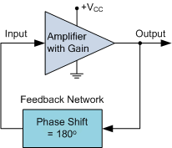
In an RC Oscillator circuit the input is shifted 180º through the feedback circuit returning the signal out-of-phase and 180º again through an inverting amplifier stage to produces the required positive feedback. This then gives us “180º + 180º = 360º” of phase shift which is effectively the same as 0º, thereby giving us the required positive feedback. In other words, the total phase shift of the feedback loop should be “0” or any multiple of 360º to obtain the same effect.
In a Resistance-Capacitance Oscillator or simply known as an RC Oscillator, we can make use of the fact that a phase shift occurs between the input to a RC network and the output from the same network by using interconnected RC elements in the feedback branch, for example.

RC Phase-Shift Network
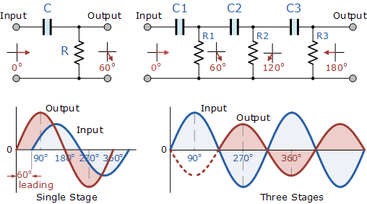

The circuit on the left shows a single resistor-capacitor network whose output voltage “leads” the input voltage by some angle less than 90º. In a pure or ideal single-pole RC network. it would produce a maximum phase shift of exactly 90º, and because 180º of phase shift is required for oscillation, at least two single-poles networks must be used within an RC oscillator design.
However in reality it is difficult to obtain exactly 90º of phase shift for each RC stage so we must therefore use more RC stages cascaded together to obtain the required value at the oscillation frequency. The amount of actual phase shift in the circuit depends upon the values of the resistor (R) and the capacitor (C), at the chosen frequency of oscillations with the phase angle ( φ ) being given as:

RC Phase Angle
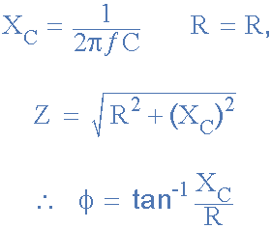

Where: X_{C} is the Capacitive Reactance of the capacitor, R is the Resistance of the resistor, and ƒ is the Frequency.
In our simple example above, the values of R and C have been chosen so that at the required frequency the output voltage leads the input voltage by an angle of about 60º. Then the phase angle between each successive RC section increases by another 60º giving a phase difference between the input and output of 180º (3 x 60º).
We know that in an amplifier circuit either using a Bipolar Transistor or an Inverting Operational Amplifier configuration, it will produce a phase-shift of 180º between its input and output. If a three-stage RC phase-shift network is connected as a feedback network between the output and input of an amplifier circuit, then the total phase shift created to produce the required regenerative feedback is: 3 x 60º + 180º = 360º = 0º as shown.
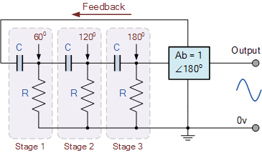

The three RC stages are cascaded together to obtain the required slope for a stable oscillation frequency. The feedback loop phase shift is -180º when the phase shift of each stage is -60º.

Basic RC Oscillator Circuit
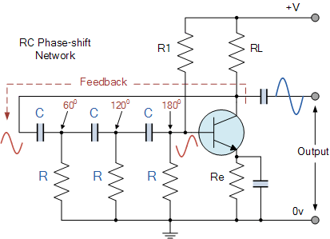

The basic RC Oscillator which is also known as a Phase-shift Oscillator, produces a sine wave output signal using regenerative feedback obtained from the resistor-capacitor (RC) ladder network. This regenerative feedback from the RC network is due to the ability of the capacitor to store an electric charge, (similar to the LC tank circuit).
This resistor-capacitor feedback network can be connected as shown above to produce a leading phase shift (phase advance network) or interchanged to produce a lagging phase shift (phase retard network) the outcome is still the same as the sine wave oscillations only occur at the frequency at which the overall phase-shift is 360º.
By varying one or more of the resistors or capacitors in the phase-shift network, the frequency can be varied and generally this is done by keeping the resistors the same and using a 3-ganged variable capacitor because capacitive reactance (X_{C}) changes with a change in frequency as capacitors are frequency-sensitive components. However, it may be required to re-adjust the voltage gain of the amplifier for the new frequency.

The Op-amp RC Oscillator
When used as RC oscillators, Operational Amplifier RC Oscillators are more common than their bipolar transistors counterparts. The oscillator circuit consists of a negative-gain operational amplifier and a three section RC network that produces the 180º phase shift. The phase shift network is connected from the op-amps output back to its “inverting” input as shown below.

Op-amp Phase-lead RC Oscillator Circuit
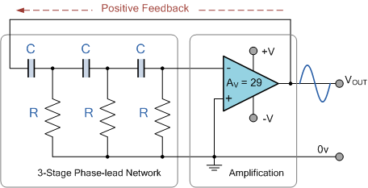

As the feedback is connected to the inverting input, the operational amplifier is therefore connected in its “inverting amplifier” configuration which produces the required 180ºphase shift while the RC network produces the other 180º phase shift at the required frequency (180º + 180º).

Op-amp Phase-lag RC Oscillator Circuit
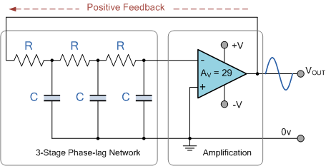

If the three resistors, R are equal in value, that is R₁ = R₂ = R₃, and the capacitors, C in the phase shift network are also equal in value, C₁ = C₂ = C₃, then the frequency of oscillations produced by the RC oscillator is simply given as:
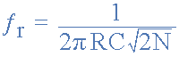
- Where:
- ƒ_{r} is the oscillators output frequency in Hertz
- R is the feedback resistance in Ohms
- C is the feddback capacitance in Farads
- N is the number of RC feedback stages.

This is the frequency at which the phase shift circuit oscillates. In our simple example above, the number of stages is given as three, so N = 3 (√2*3 = √6). For a four stage RC network, N = 4 (√2*4 = √8), etc.

RC Oscillators are stable and provide a well-shaped sine wave output with the frequency being proportional to 1/RC and therefore, a wider frequency range is possible when using a variable capacitor. However, RC Oscillators are restricted to frequency applications because of their bandwidth limitations to produce the desired phase shift at high frequencies.

Wien Bridge Oscillator.
The Wien Bridge Oscillator is so called because the circuit is based on a frequency-selective form of the Wheatstone bridge circuit. The Wien Bridge oscillator is a two-stage RC coupled amplifier circuit that has good stability at its resonant frequency, low distortion and is very easy to tune making it a popular circuit as an audio frequency oscillator but the phase shift of the output signal is considerably different from the previous phase shift RC Oscillator.
The Wien Bridge Oscillator uses a feedback circuit consisting of a series RC circuit connected with a parallel RC of the same component values producing a phase delay or phase advance circuit depending upon the frequency. At the resonant frequency ƒr the phase shift is 0º. Consider the circuit below.

RC Phase Shift Network
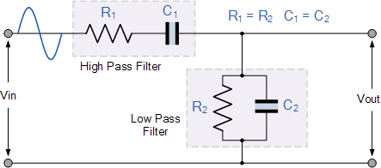

The above RC network consists of a series RC circuit connected to a parallel RC forming basically a High Pass Filter connected to a Low Pass Filter producing a very selective second-order frequency dependant Band Pass Filter with a high Q factor at the selected frequency, ƒr.
At low frequencies the reactance of the series capacitor (C1) is very high so acts a bit like an open circuit, blocking any input signal at Vin resulting in virtually no output signal, Vout. Likewise, at high frequencies, the reactance of the parallel capacitor, (C2) becomes very low, so this parallel connected capacitor acts a bit like a short circuit across the output, so again there is no output signal.
So there must be a frequency point between these two extremes of C1 being open-circuited and C2 being short-circuited where the output voltage, V_{OUT} reaches its maximum value. The frequency value of the input waveform at which this happens is called the oscillators Resonant Frequency, (ƒr).
At this resonant frequency, the circuits reactance equals its resistance, that is: Xc = R, and the phase difference between the input and output equals zero degrees. The magnitude of the output voltage is therefore at its maximum and is equal to one third (1/3) of the input voltage as shown.

Oscillator Output Gain and Phase Shift
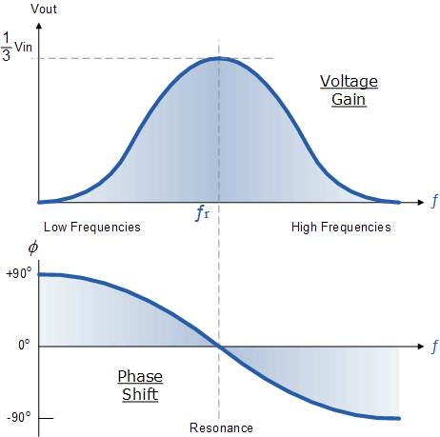

It can be seen that at very low frequencies the phase angle between the input and output signals is “Positive” (Phase Advanced), while at very high frequencies the phase angle becomes “Negative” (Phase Delay). In the middle of these two points the circuit is at its resonant frequency, (ƒr) with the two signals being “in-phase” or 0º. We can therefore define this resonant frequency point with the following expression.

Wien Bridge Oscillator Frequency
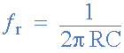
- Where:
- ƒr is the Resonant Frequency in Hertz
- R is the Resistance in Ohms
- C is the Capacitance in Farads
We said previously that the magnitude of the output voltage, Vout from the RC network is at its maximum value and equal to one third (1/3) of the input voltage, Vin to allow for oscillations to occur. But why one third and not some other value. In order to understand why the output from the RC circuit above needs to be one-third, that is 0.333xVin, we have to consider the complex impedance (Z = R ± jX) of the two connected RC circuits.
We know from our AC Theory tutorials that the real part of the complex impedance is the resistance, R while the imaginary part is the reactance, X. As we are dealing with capacitors here, the reactance part will be capacitive reactance, Xc.

The RC Network
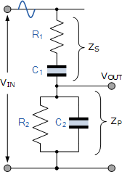
If we redraw the above RC network as shown, we can clearly see that it consists of two RC circuits connected together with the output taken from their junction. Resistor R₁ and capacitor C₁ form the top series network, while resistor R₂ and capacitor C₂ form the bottom parallel network.
Therefore the total DC impedance of the series combination (R₁C₁) we can call, Z_{S} and the total impedance of the parallel combination (R₂C₂) we can call, Z_{P}. As Z_{S} and Z_{P} are effectively connected together in series across the input, V_{IN}, they form a voltage divider network with the output taken from across Z_{P} as shown.
Lets assume then that the component values of R₁ and R₂ are the same at: 12kΩ, capacitors C₁ and C₂ are the same at: 3.9nF and the supply frequency, ƒ is 3.4kHz.

Series Circuit
The total impedance of the series combination with resistor, R₁ and capacitor, C₁ is simply:
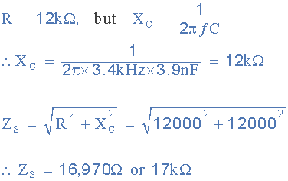

We now know that with a supply frequency of 3.4kHz, the reactance of the capacitor is the same as the resistance of the resistor at 12kΩ. This then gives us an upper series impedance Z_{S} of 17kΩ.
For the lower parallel impedance Z_{P}, as the two components are in parallel, we have to treat this differently because the impedance of the parallel circuit is influenced by this parallel combination.

Parallel Circuit
The total impedance of the lower parallel combination with resistor, R₂ and capacitor, C₂is given as:
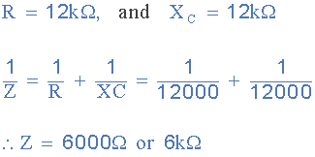

At the supply frequency of 3400Hz, or 3.4kHz, the combined DC impedance of the RC parallel circuit becomes 6kΩ (R||Xc) with the vector sum of this parallel impedance being calculated as:
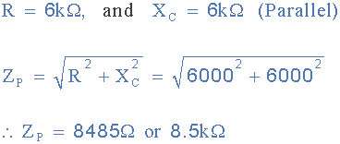

So we now have the value for the vector sum of the series impedance: 17kΩ, ( Z_{S} = 17kΩ ) and for the parallel impedance: 8.5kΩ, ( Z_{P} = 8.5kΩ ). Therefore the total output impedance, Zout of the voltage divider network at the given frequency is:
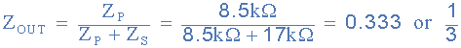

Then at the oscillation frequency, the magnitude of the output voltage, Vout will be equal to Zout x Vin which as shown is equal to one third (1/3) of the input voltage, Vin and it is this frequency selective RC network which forms the basis of the Wien Bridge Oscillatorcircuit.
If we now place this RC network across a non-inverting amplifier which has a gain of 1+R1/R2 the following basic Wien bridge oscillator circuit is produced.

Wien Bridge Oscillator
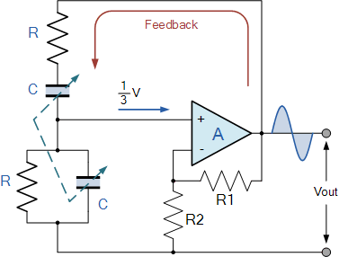

The output of the operational amplifier is fed back to both the inputs of the amplifier. One part of the feedback signal is connected to the inverting input terminal (negative or degenerative feedback) via the resistor divider network of R1 and R2 which allows the amplifiers voltage gain to be adjusted within narrow limits.
The other part, which forms the series and parallel combinations of R and C forms the feedback network and are fed back to the non-inverting input terminal (positive or regenerative feedback) via the RC Wien Bridge network and it is this positive feedback combination that gives rise to the oscillation.
The RC network is connected in the positive feedback path of the amplifier and has zero phase shift a just one frequency. Then at the selected resonant frequency, ( ƒr ) the voltages applied to the inverting and non-inverting inputs will be equal and “in-phase” so the positive feedback will cancel out the negative feedback signal causing the circuit to oscillate.
The voltage gain of the amplifier circuit MUST be equal too or greater than three “Gain = 3” for oscillations to start because as we have seen above, the input is 1/3 of the output. This value, ( Av ≥ 3 ) is set by the feedback resistor network, R1 and R2 and for a non-inverting amplifier this is given as the ratio 1+(R1/R2).

